Interacting with Tables and Data

01. Write the SQL statements that you used to remove from the database the 3 tables that you had created earlier in Lab Exercise 1. Do not drop the constraints or use code with keywords like cascade constraints that automatically drop referential integrity constraints. (AKA follow the rules!)

USE Employees
DROP TABLE Timesheet;
DROP TABLE Employee;
DROP TABLE Job;

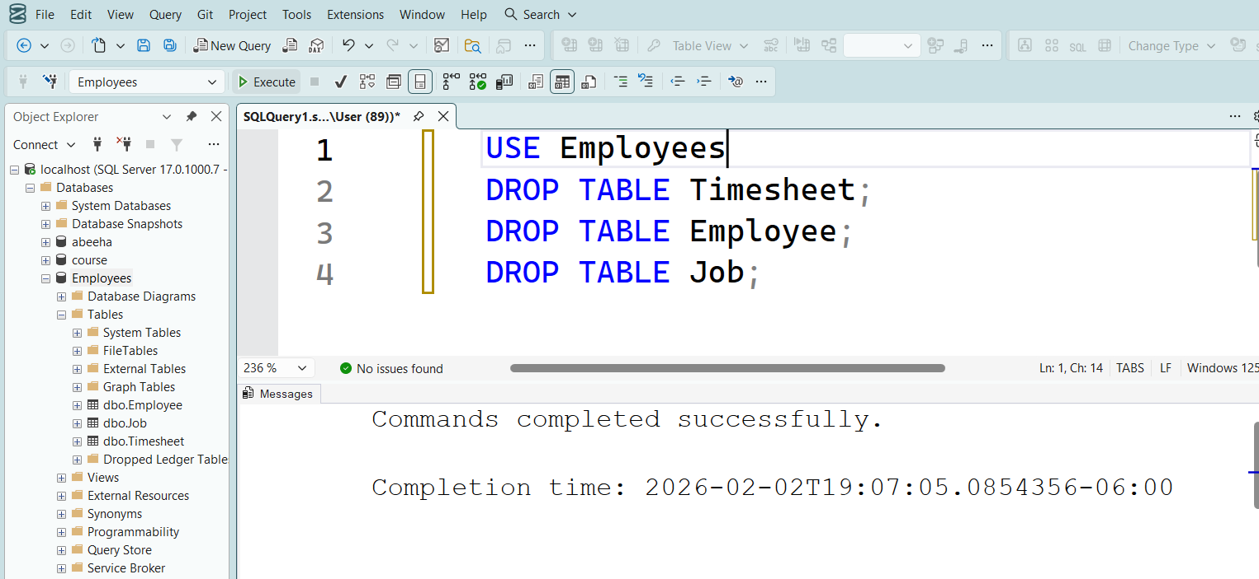

02. In a comment, list the order in which you dropped these 3 tables from the database. Is the order in which these 3 tables were dropped important? Explain.

Order of dropping: 1. Timesheet (child), 2. Employee (parent), 3. Job (grandparent).
Importance of order: Yes, the order is important. We must drop the "child" tables (those containing foreign keys) before the "parent" tables to avoid violating referential integrity constraints.

03. Use the SQL scripts from the previous lab to create and populate the Job, Employee, and Timesheet tables that you just dropped.
Use Employees
CREATE TABLE Job (
JobCode INT PRIMARY KEY,
[Description] VARCHAR(25),
RayRate NUMERIC(4,2));
CREATE TABLE Employee (
EmpID Numeric(5) PRIMARY KEY,
SIN INT NOT NULL UNIQUE,
LastName VARCHAR(25) NOT NULL,
FirstName VARCHAR(25),
Street VARCHAR(30),
City VARCHAR(25),
Province CHAR(2),
PostalCode VARCHAR(7),
JobCode INT,
IncomeTax CHAR(1),
BirthDate DATE,
HireDate DATE,
JobCodeDate DATE,
FOREIGN KEY (JobCode) REFERENCES Job(JobCode));
CREATE TABLE Timesheet (
EmpID Numeric,
PayWeekEndDate DATE,
RegHours INT,
OTimeHours NUMERIC(5,2),
PRIMARY KEY (EmpID, PayWeekEndDate));

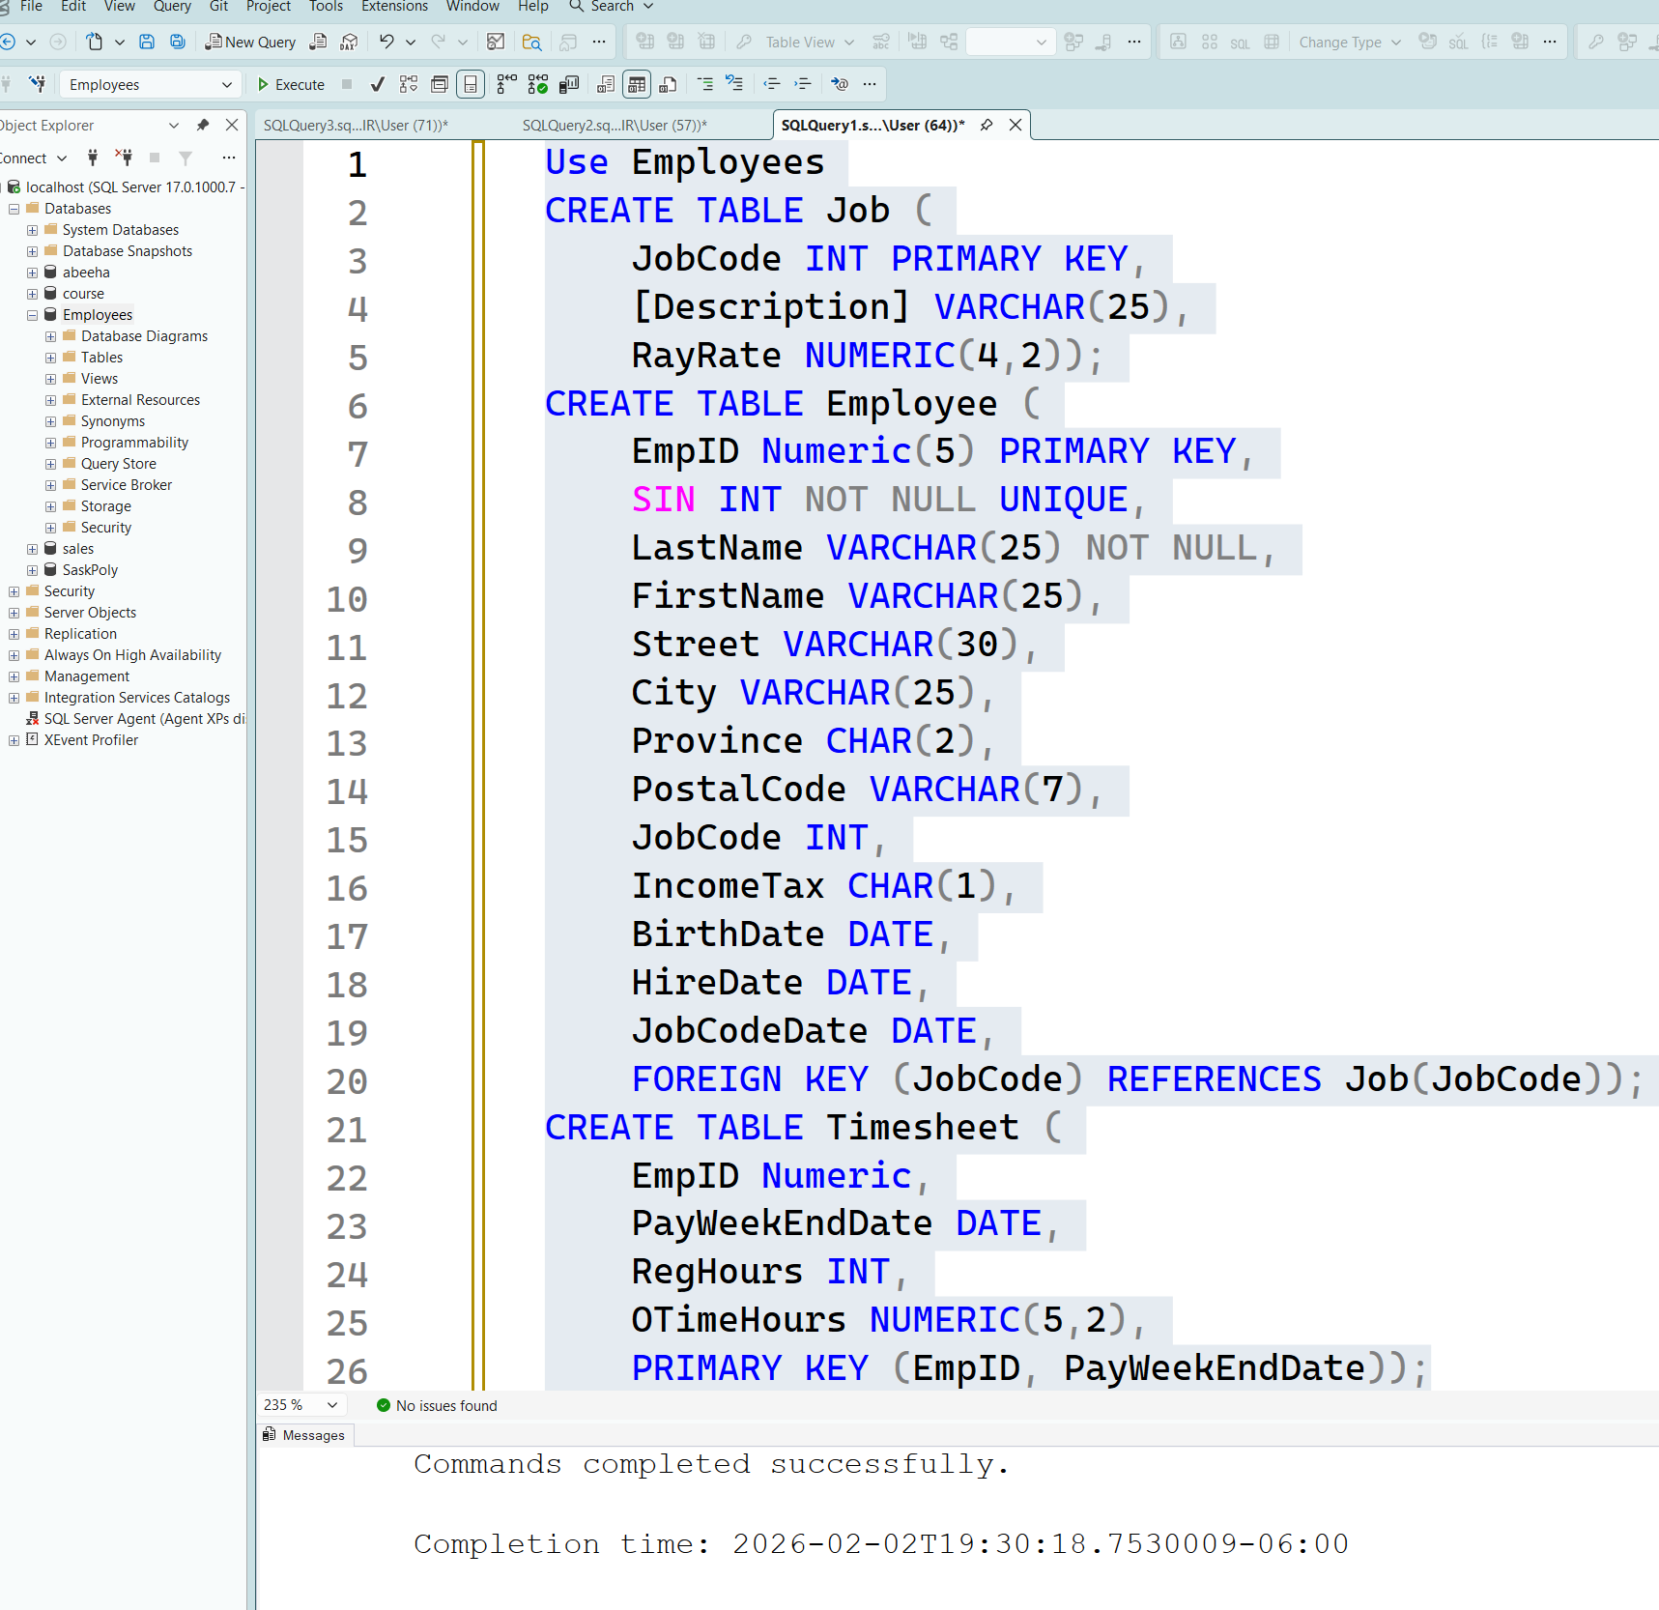

04. Use SQL to create the Earnings and the Deductions tables that are shown below. Please follow the guidelines listed below for each column’s name, data type and constraints. Use the Foreign Key to link the tables. Once the tables have been created in the database, save your SQL scripts for future use. You can save all your scripts in a single file or place the code for each table in a separate file. See the end of the assignment for data insert scripts, include these scripts in this question so you can easily recreate these tables.
Earnings
Attribute | Data Type | Constraints | Comments
EmpID | Numeric(5) | Primary Key, Foreign Key
PayWeekEndDate | Date | Primary Key, Foreign Key
RegEarnings | Numeric(6,2) |  | Earnings at regular pay
OTimeEarnings | Numeric(6,2) |  | Earnings at overtime pay (double the regular pay rate)

Use Employees
CREATE TABLE Earnings (
EmpID Numeric(5),
PayWeekEndDate Date,
RegEarnings Numeric(6,2),
OTimeEarnings Numeric(6,2),
CONSTRAINT pk_earnings PRIMARY KEY (EmpID, PayWeekEndDate),
CONSTRAINT fk_earnings_emp FOREIGN KEY (EmpID) REFERENCES Employee(EmpID));
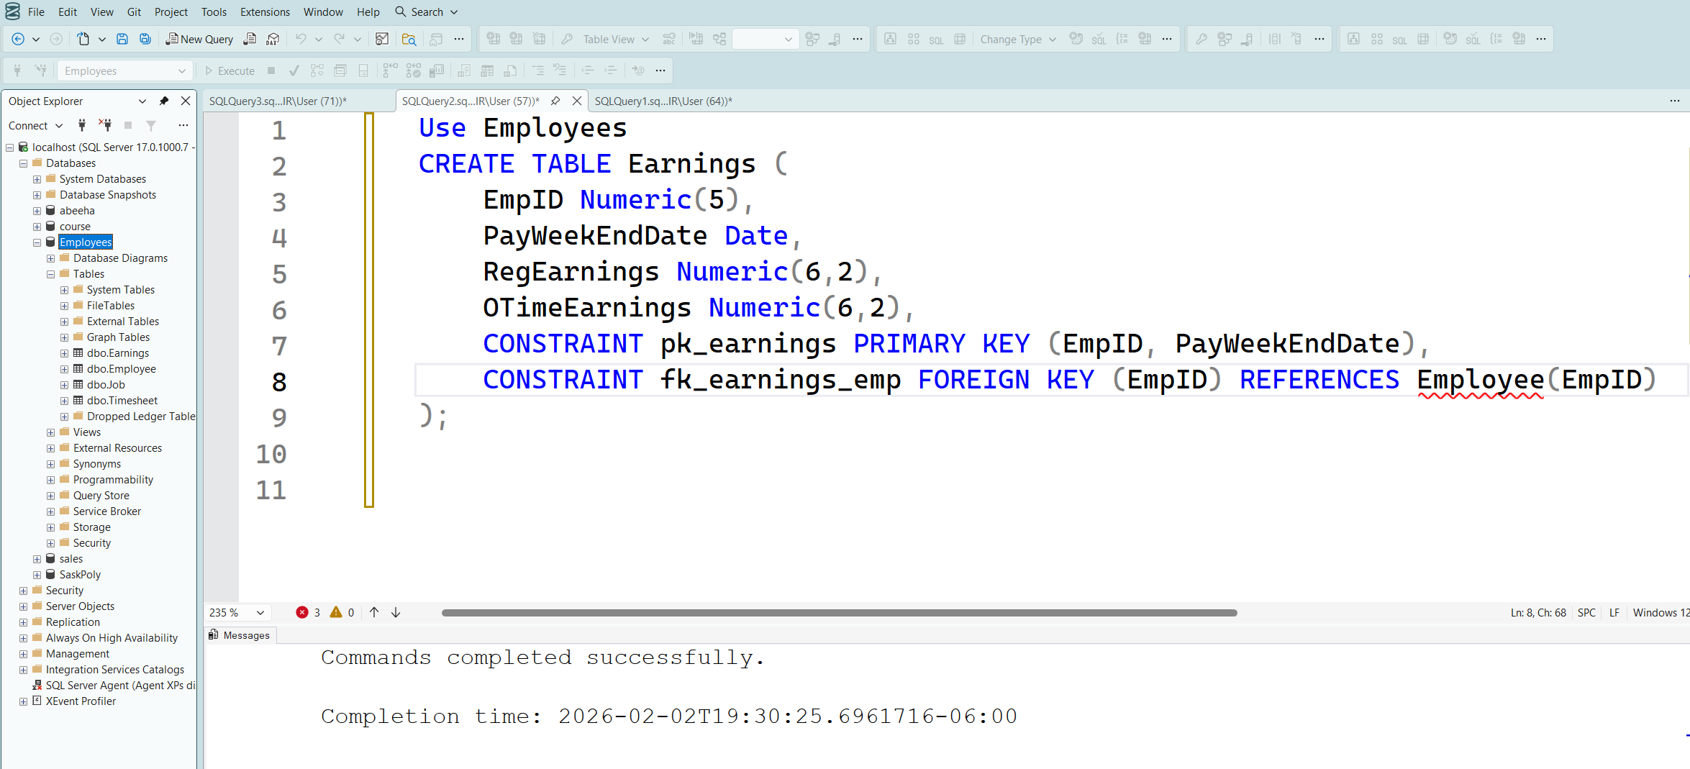

Deductions
Attribute | Data Type | Constraints | Comments
EmpID | Numeric(5) | Primary Key, Foreign Key
PayWeekEndDate | Date | Primary Key, Foreign Key
EI | Numeric(5,2) |  | Employment Insurance 1.5% total pre tax earnings
CPP | Numeric (5,2) |  | Canada Pension Plan  2.5% total pre tax earnings
UnionDues | Numeric(5,2) |  | 5% total pre tax earnings
PensionPlan | Numeric(5,2) |  | 1% total pre tax earnings
IncomeTax | Numeric(6,2) |  | 17% total pre tax earnings of employees who pay tax; NULL for employees who don’t pay tax

CREATE TABLE Deductions (
EmpID Numeric(5),
PayWeekEndDate Date,
EI Numeric(5,2),
CPP Numeric(5,2),
UnionDues Numeric(5,2),
PensionPlan Numeric(5,2),
IncomeTax Numeric(6,2),
CONSTRAINT pk_deductions PRIMARY KEY (EmpID, PayWeekEndDate),
CONSTRAINT fk_deductions_emp FOREIGN KEY (EmpID) REFERENCES Employee(EmpID) );

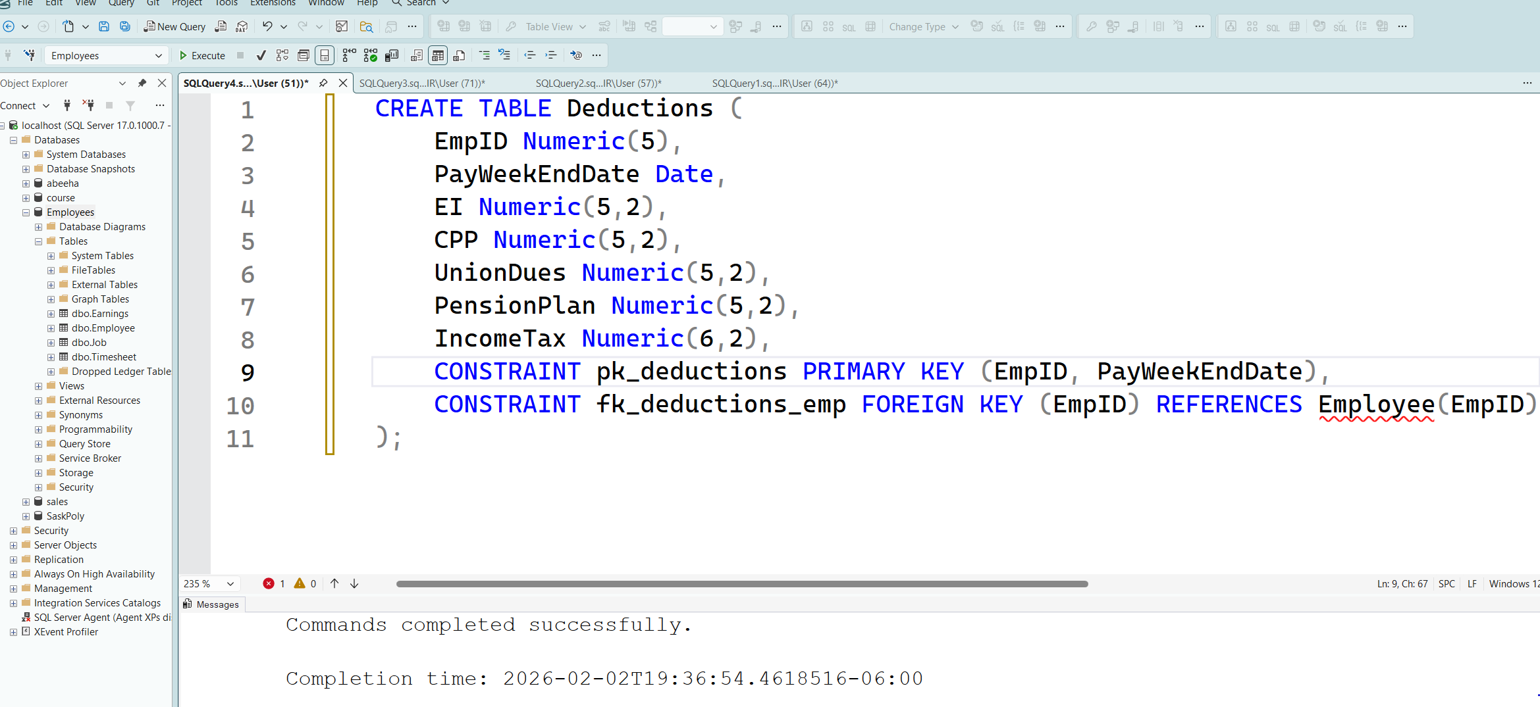

05. In a comment, list the order in which you created these 2 tables. Is the order in which these 2 tables were created important?
- Order of creation: 1. Earnings, 2. Deductions (or vice versa, as they do not depend on each other).
- Is the order important? No, the order between these two specific tables is not important because neither references the other as a foreign key.

06. Would you be able to create the Earnings and the Deductions tables before you had created the Job, Employee, and Timesheet tables? Explain.
Dependency Check: I cannot create Earnings and Deductions before Job, Employee, and Timesheet. This is because both new tables require the EmpID from the Employee table to establish their foreign key relationships.

07. Write the SQL code to display all the records in the Earnings table.

SELECT * FROM earnings;

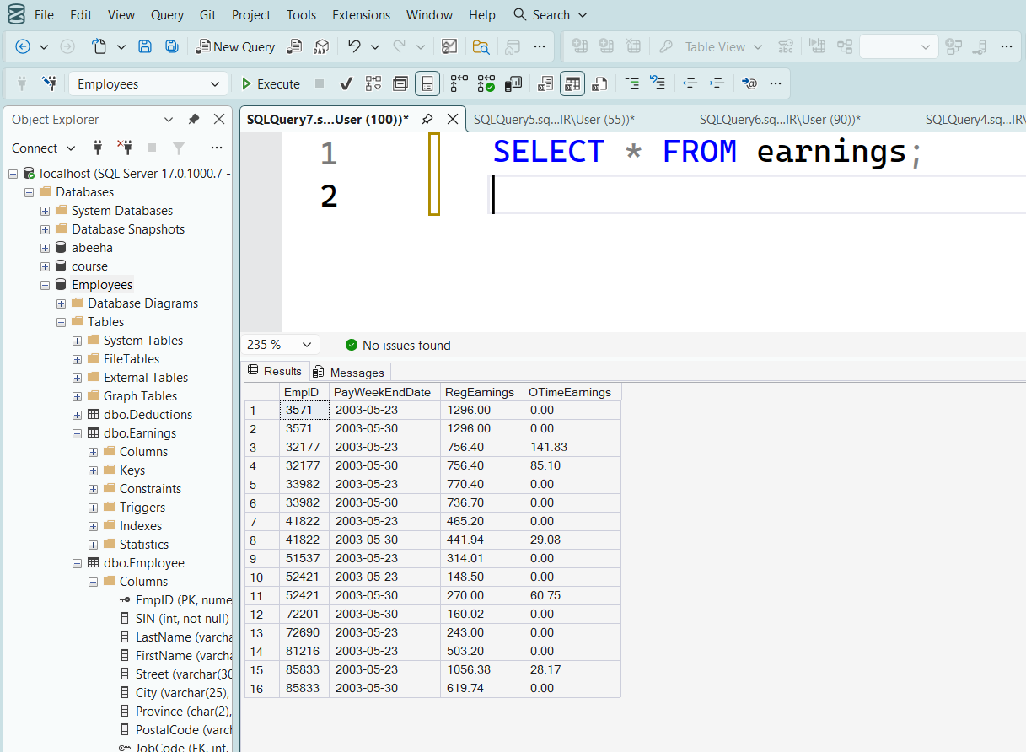

08. Write the SQL code to show the structure of the Deductions table.

EXEC sp_help 'Deductions';

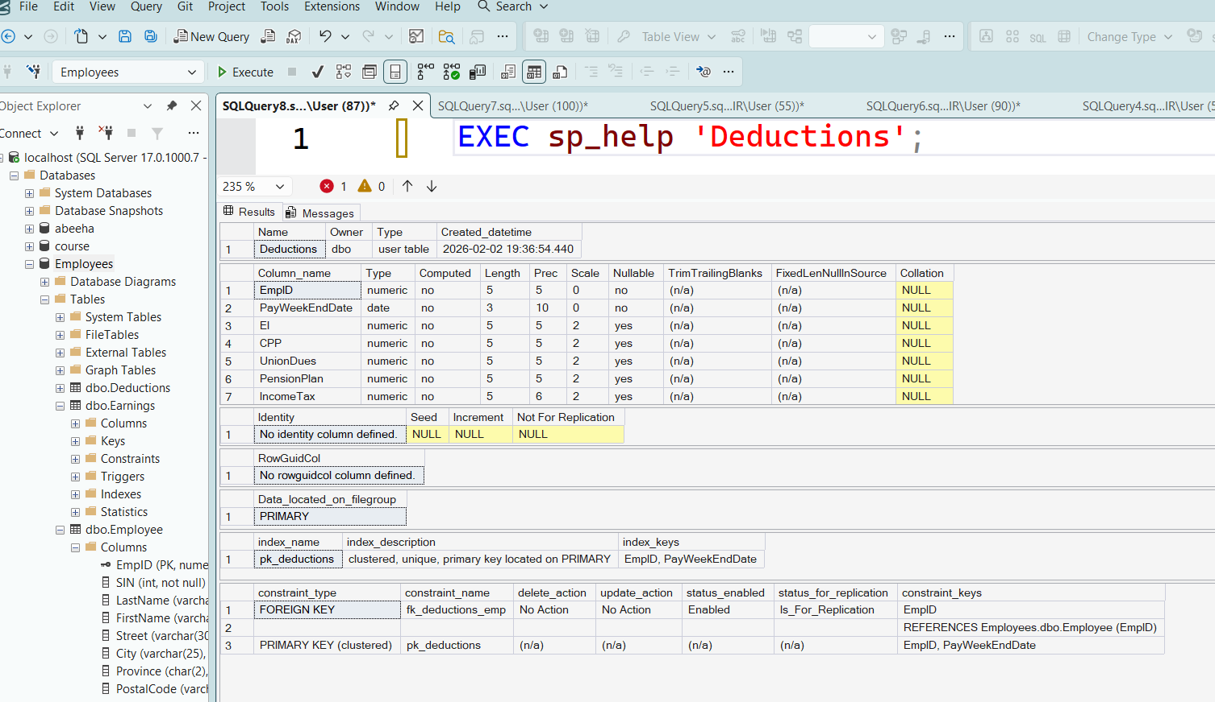

09. Write the SQL code to display today’s date. (Hint there is a function for this).

SELECT GETDATE() AS [Today's Date];

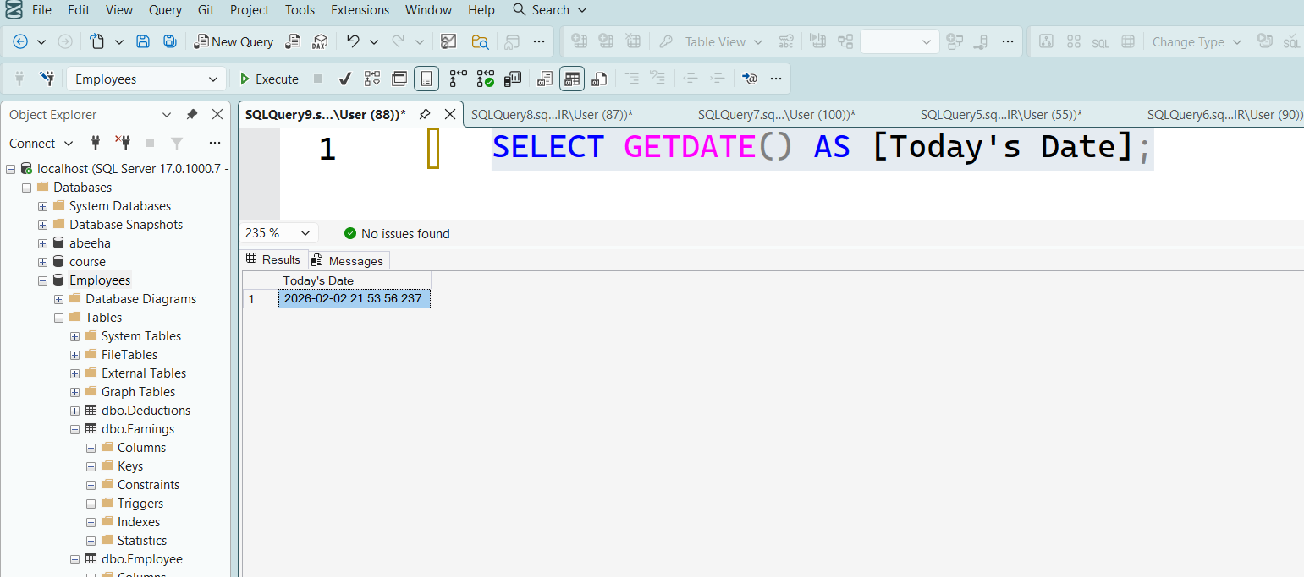

10. For this question assume there are employees who live in NF (Newfoundland). Write the SQL code to change the province to NL for these employees only.
USE Employees
UPDATE Employee
SET Province = 'NL'
WHERE Province = 'NF';

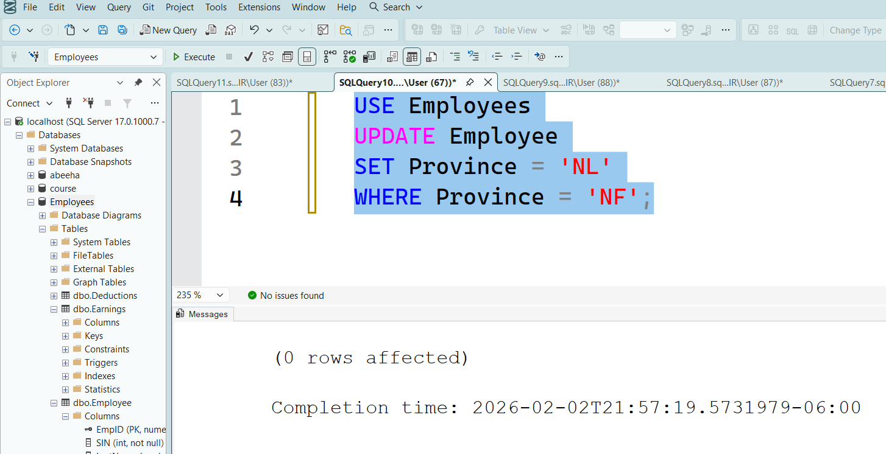

11. Write the SQL code to delete from the Employee table only the records of those employees who do not pay income tax. For this question you can ignore/assume there are no child records in other tables.

DELETE FROM Employee
WHERE EmpID IN (
SELECT EmpID
FROM Deductions
WHERE IncomeTax IS NULL);

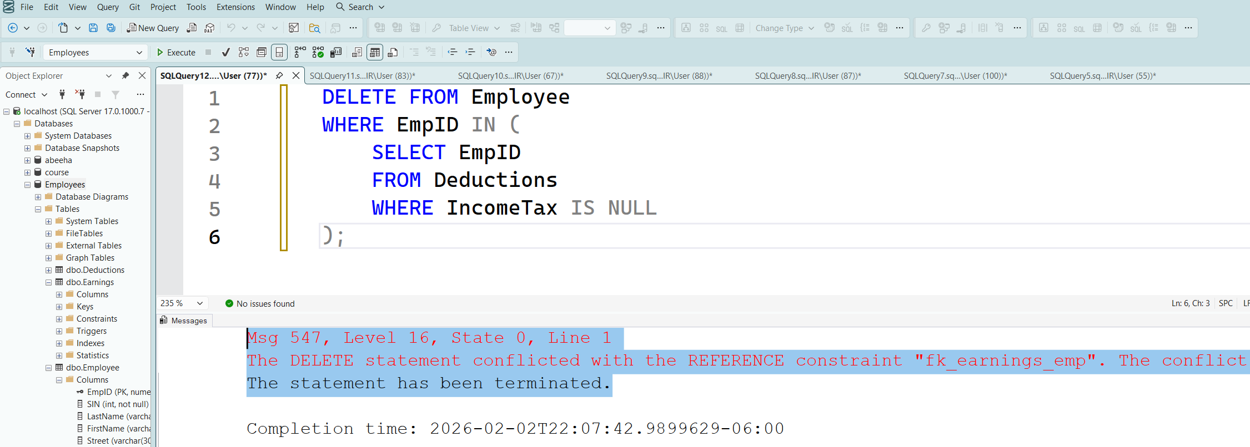

Note:
Execution order:
Run these statements in this specific order to satisfy the database constraints:
- Delete from Earnings first: Remove the payment records for those specific employees.
SQL
DELETE FROM Earnings
WHERE EmpID IN (SELECT EmpID FROM Deductions WHERE IncomeTax IS NULL);
- Delete from Deductions second: Remove the tax records for those specific employees.
SQL
DELETE FROM Deductions
WHERE IncomeTax IS NULL;
- Delete from Employee last: Now that the child records are gone, you can remove the employees.
SQL
DELETE FROM Employee
WHERE EmpID IN (SELECT EmpID FROM Deductions WHERE IncomeTax IS NULL);

Scripts for Question 4:
-- Insert records into Earnings table
INSERT INTO earnings VALUES (33982,'23-May-03',770.4,0);
INSERT INTO earnings VALUES (33982,'30-May-03',736.7,0);
INSERT INTO earnings VALUES (51537,'23-May-03',314.01,0);
INSERT INTO earnings VALUES (41822,'23-May-03',465.2,0);
INSERT INTO earnings VALUES (41822,'30-May-03',441.94,29.08);
INSERT INTO earnings VALUES (3571,'23-May-03',1296,0);
INSERT INTO earnings VALUES (3571,'30-May-03',1296,0);
INSERT INTO earnings VALUES (85833,'23-May-03',1056.38,28.17);
INSERT INTO earnings VALUES (85833,'30-May-03',619.74,0);
INSERT INTO earnings VALUES (81216,'23-May-03',503.2,0);
INSERT INTO earnings VALUES (32177,'23-May-03',756.4,141.83);
INSERT INTO earnings VALUES (32177,'30-May-03',756.4,85.1);
INSERT INTO earnings VALUES (52421,'23-May-03',148.5,0);
INSERT INTO earnings VALUES (52421,'30-May-03',270,60.75);
INSERT INTO earnings VALUES (72690,'23-May-03',243,0);
INSERT INTO earnings VALUES (72201,'30-May-03',160.02,0);

-- Insert records into Deductions table
INSERT INTO Deductions VALUES (33982,'23-May-03',11.56,19.26,38.52,7.7,130.97);
INSERT INTO Deductions VALUES (33982,'30-May-03',11.05,18.42,36.84,7.37,125.24);
INSERT INTO Deductions VALUES (51537,'23-May-03',4.71,7.85,15.7,3.14,53.38);
INSERT INTO Deductions VALUES (41822,'23-May-03',6.98,11.63,23.26,4.65,79.08);
INSERT INTO Deductions VALUES (41822,'30-May-03',7.07,11.78,23.55,4.71,80.07);
INSERT INTO Deductions VALUES (3571,'23-May-03',19.44,32.4,64.8,12.96,220.32);
INSERT INTO Deductions VALUES (3571,'30-May-03',19.44,32.4,64.8,12.96,220.32);
INSERT INTO Deductions VALUES (85833,'23-May-03',16.27,27.11,54.23,10.85,184.37);
INSERT INTO Deductions VALUES (85833,'30-May-03',9.3,15.49,30.99,6.2,105.36);
INSERT INTO Deductions VALUES (81216,'23-May-03',7.55,12.58,25.16,5.03,85.54);
INSERT INTO Deductions VALUES (32177,'23-May-03',13.47,22.46,44.91,8.98,152.7);
INSERT INTO Deductions VALUES (32177,'30-May-03',12.62,21.04,42.08,8.42,143.06);
INSERT INTO Deductions VALUES (52421,'23-May-03',2.23,3.71,7.43,1.49,25.25);
INSERT INTO Deductions VALUES (52421,'30-May-03',4.96,8.27,16.54,3.31,56.23);
INSERT INTO Deductions VALUES (72690,'23-May-03',3.65,6.08,12.15,2.43,null);
INSERT INTO Deductions VALUES (72201,'30-May-03',2.4,4,8,1.6,null);

